Introduction
The kidney plays a pivotal role in regulating and thereby maintaining the normal body water osmolarity and content. In this laboratory, you will examine the effects of drinking ‘water’ (distilled), isosmotic salt solution and hyperosmotic glucose solution.

Background

It is essential to life that body water content is maintained and regulated. Too little water can result in cellular and extracellular dehydration and eventual death; too much water leads to cell swelling and death. In people of average body build, water makes up about 60% of the body water in males and 55% in females. This difference reflects the fact that females normally have a slightly higher proportion of their body weight in fat, and fat cells contain little water. Of this body water, two thirds is in the cells and one third is extracellular, with the plasma comprising about 20% of the total extracellular fluid volume. The other 80% lies between the capillary walls and the cells and is called the interstitial fluid.

Body water balance
Normally we remain in water balance. Over 24 hours we lose water by insensible evaporative loss from the lungs in breathing and from the skin (about 500 ml from each) and a little fluid in the feces (about 100 ml). During exercise, losses from breathing will increase and in hot climates additional water is lost as sweat, the evaporation of which from the skin cools the body. With severe prolonged exercise sweating can result in losses of as much as 1000 ml/hour. In addition, we must lose about 500 ml of water in the urine to excrete metabolic waste products at the maximum urinary concentration that we can achieve (some 1200 mosmol/liter).
Our fluid intake must replace these losses. Actually, we normally drink more water than is needed so that we excrete a relatively dilute urine.

Water homeostasis
Two homeostatic reflex mechanisms work together to control body water content - thirst and the ADH system. The major stimulus to both is a change in plasma osmolarity that is detected principally by receptors in the supra-optic and paraventricular nuclei in the hypothalamus. In this region of the brain, the blood-brain barrier is deficient so that neurons in these nuclei are exposed directly to changes in blood osmolarity. An increase in osmolarity will result in water leaving the neurons, thus decreasing the cell volume; a decrease in osmolarity will result in water entering the neurons, thus increasing the cell volume.
Increased osmolarity detected by these neurons results in the sensation of thirst and the release of ADH, a hormone synthesized by these cells and stored in their nerve endings that are found in the posterior pituitary (neurohypophysis or pars nervosa) from which the release occurs (Figure 1).
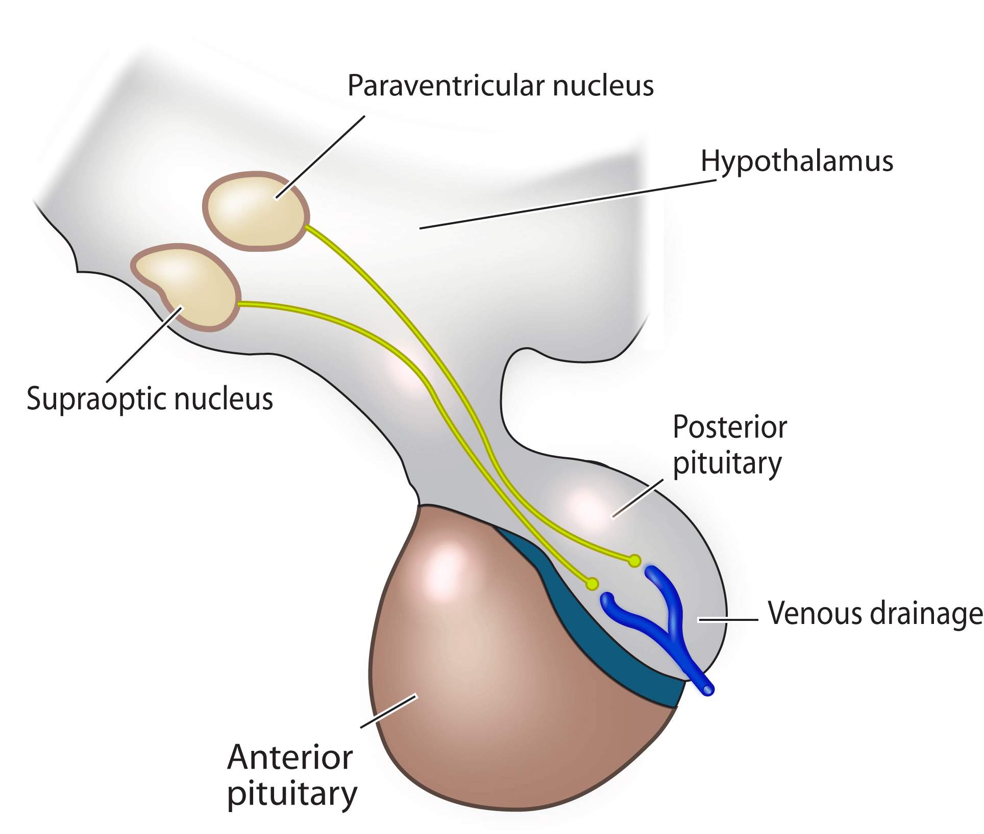
Figure 1. Hypothalamic-pituitary axis.

Thirst results in seeking out and drinking fluid; ADH causes the kidneys to retain water. The combination of increased intake and decreased loss rapidly restores the plasma osmolarity to normal. However, it is important to appreciate that the rapidity with which the thirst response can contribute to the restoration of plasma osmolarity depends upon the rate at which fluid is absorbed from the gut. Since virtually no water is absorbed from the stomach, the rate of water absorption is determined by the rate of gastric emptying and the osmolarity of the fluid that enters the intestine from the stomach. Rapid emptying and dilute solution allows the most rapid absorption. Because the wall of the small intestine is very water permeable, adding fluid more concentrated than the blood to the intestine from the stomach will initially remove water from the body into the intestinal lumen. Water will then be reabsorbed secondary to the solute absorption
Decreased osmolarity detected by these neurons results in suppression of the thirst sensation and inhibition of the release of ADH. This combination results in cessation of fluid intake and excretion of excess water in the urine, again restoring the plasma osmolarity to normal. Note that the half life of ADH in the plasma is short (10 too 15 min) so that once ADH secretion is suppressed, plasma ADH concentration falls quite rapidly. Its effects on the collecting duct cells in the kidney also wear off over a similar period.
Other stimuli to thirst and ADH secretion include decreased venous and arterial pressures. These are of especial importance when the circulating blood volume is diminished. However, the emphasis in this laboratory is on control of water balance in the usual physiological situation where blood volume is normal.

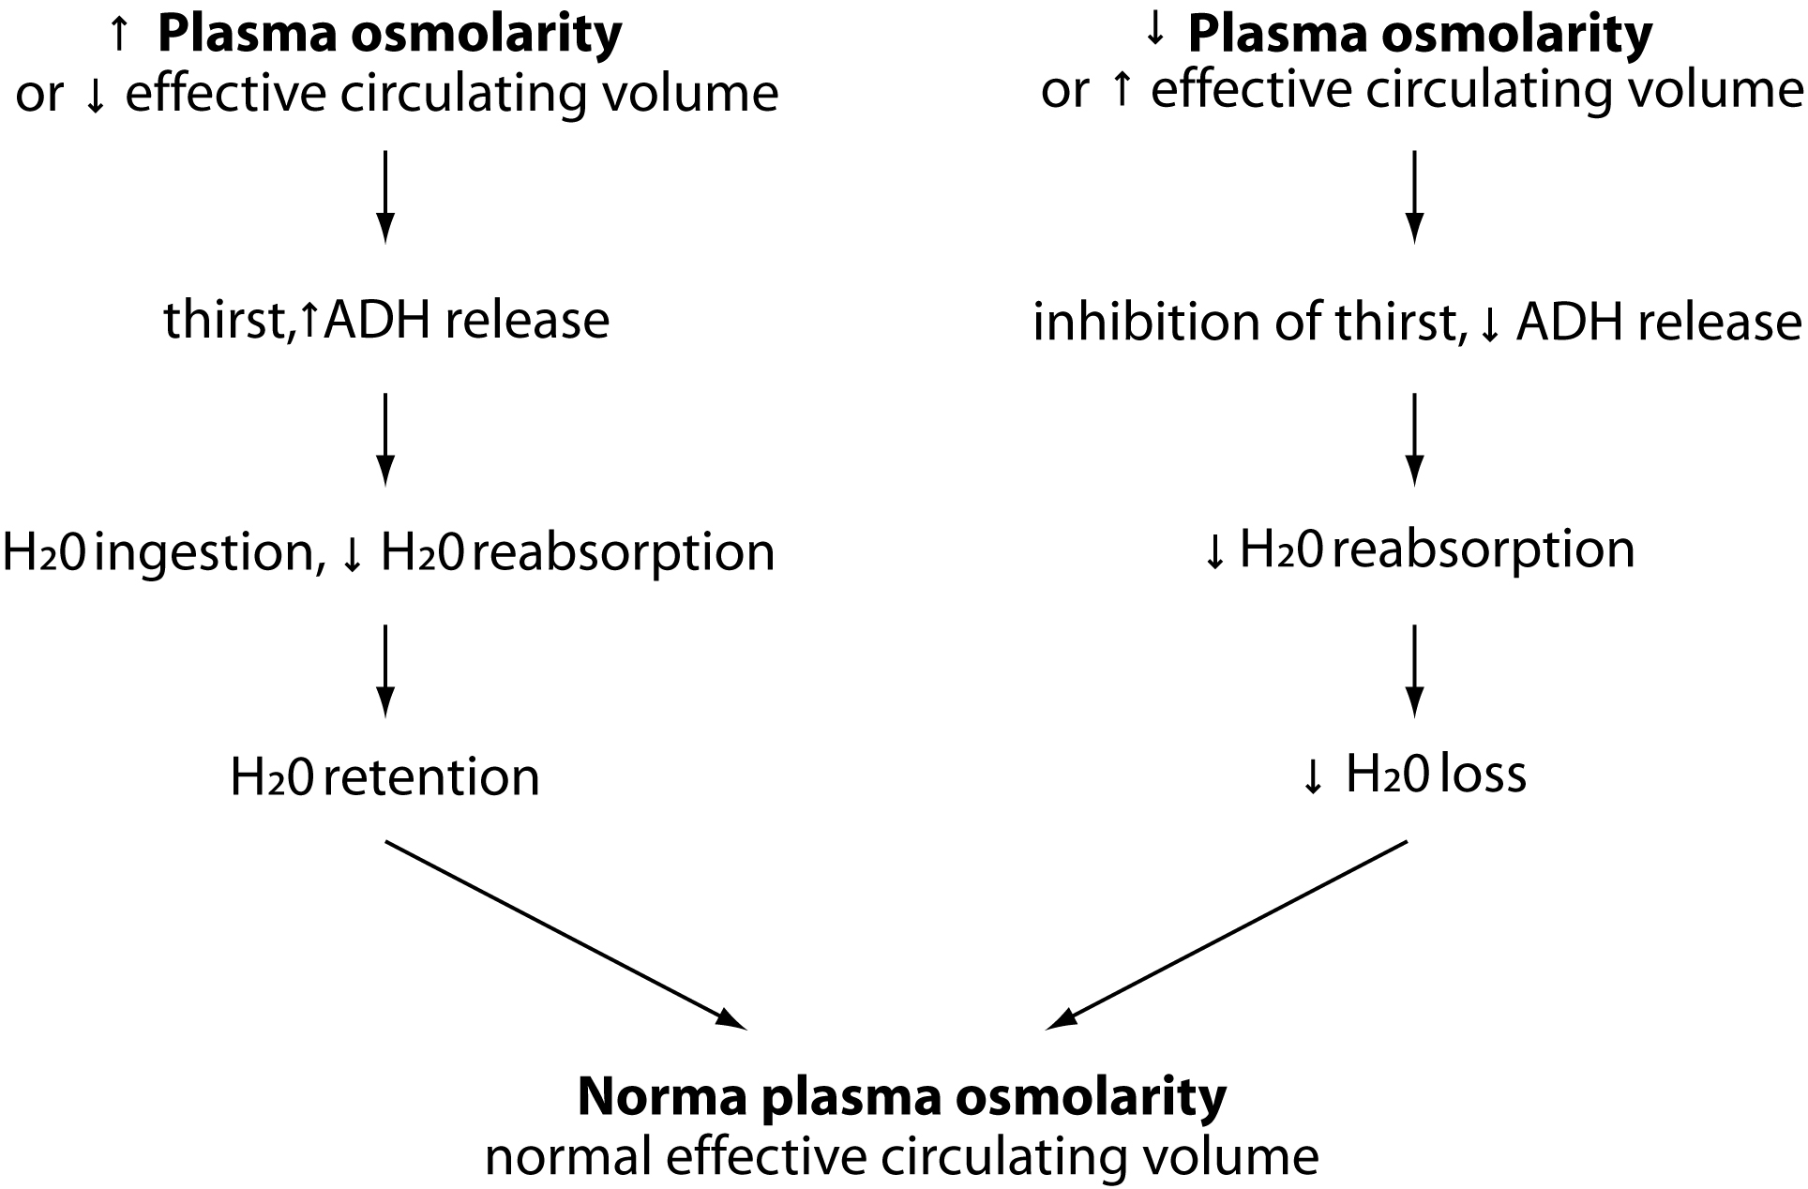

Figure 2. Control of water balance.

In addition, in certain physiological situations ADH secretion is actually stimulated independent of the plasma osmolarity. These include deep sleep and initiation of exercise, the effects of both of which are readily explained. You do not want to have to wake up from a deep sleep to urinate, and you do not want to lose water if you are beginning to exercise for it is important to maintain an adequate water reserve to allow for temperature regulation, including sweating. In contrast, alcohol inhibits ADH release and the excess loss of water and dehydration as a consequence is thought to contribute to the alcohol-related 'hangover'.

Effects of monosaccharide loads

A hyperosmotic monosacharide (largely glucose) load may initially cause a little water to pass from the plasma into the gut lumen. But monosacharides are rapidly absorbed. The absorbed fluid passes through the portal circulation to the liver where the glucose is removed leaving the water to be handled by the kidneys, just as when water alone is drunk. Note that, under normal conditions, no glucose appears in the urine following ingestion of these relatively high concentrations of glucose. The plasma glucose concentration in the systemic circulation changes relatively little because the liver is so effective in removing the absorbed glucose and hormones are released (insulin plays a major role) that stimulate muscle, adipose and other cells to take up any excess glucose. In addition, plasma glucose concentration needs to virtually double before glucose will appear in the urine. This is because the transport pathway in the apical membranes of the renal proximal tubular cells (that transports glucose and sodium together) has appreciable unused capacity.

The rapid removal of glucose from the circulation is the basis for using an intravenous isosmotic glucose solution to rehydrate patients who are water deficient. The isosmotic solution does not affect cell volume initially, so there is no hemolysis of red blood cells, and the water is released at a rate that the kidneys can handle.

Renal handling of water
In the young adult human the kidneys filter about 100 ml/min at the glomeruli (about 180 L/24 hours). Of this volume, up to 85% is reabsorbed secondary to solute reabsorption leaving about 15% of the filtered water to be excreted or retained depending on the body's needs. If the body fluids are hyperosmotic, then circulating ADH is high. This elevation results in the insertion of water channels into the apical membranes of cells lining the collecting ducts and water is reabsorbed as the fluid runs through the hyperosmotic renal medulla. If the body fluids are hypo-osmotic, then circulating ADH is decreased or even absent. Water channels are removed from the apical membranes of the collecting duct cells and the excess water is excreted in the urine.

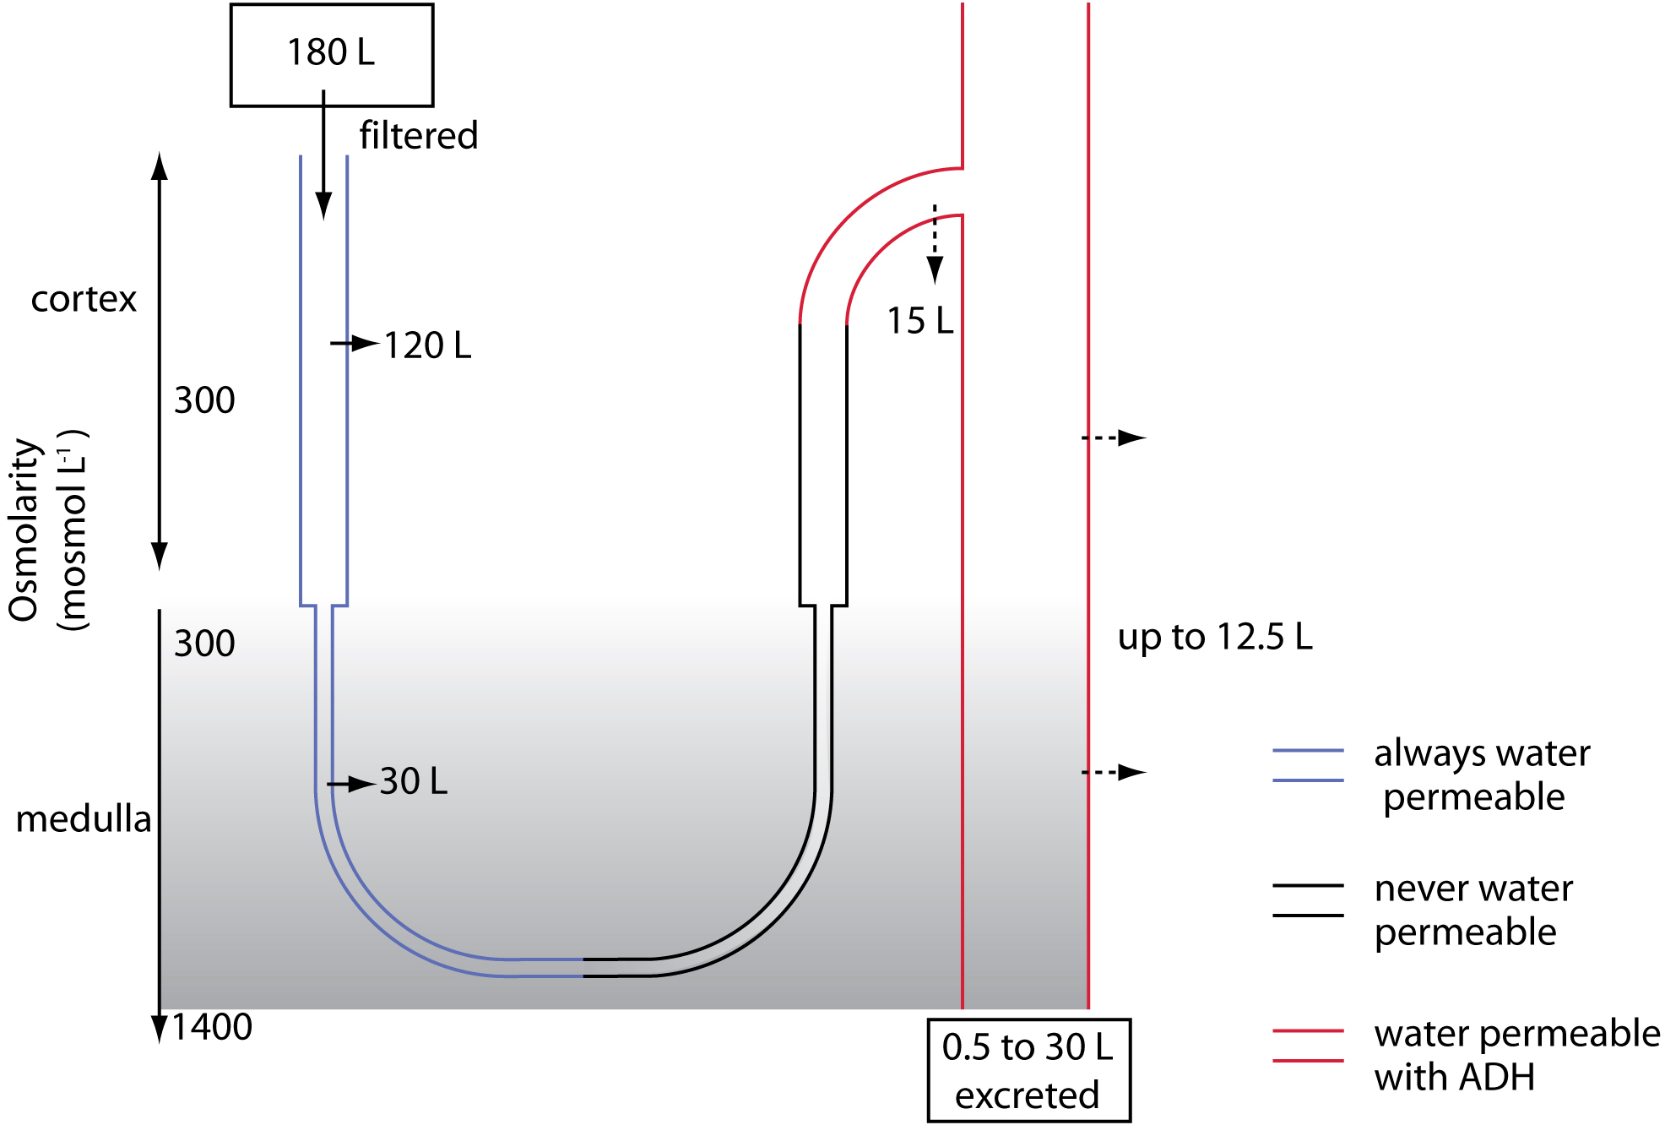

Figure 3. Summary of renal handling of 24 hour water load.

It is important to recognize that there is an upper limit to the amount of water that can be excreted per minute - certainly no more than 15 to 20 ml/min or about one liter an hour. Therefore, it is possible by drinking excessive water over a short period to over-hydrate the body; water will be retained, body fluids will be diluted and cells will swell. Because the brain lies within a rigid container (the skull), swelling of brain cells raises intracranial pressure and this in turn impairs brain blood flow. People in this situation exhibit symptoms that are similar to alcohol intoxication, thus the condition is referred to as water intoxication. This is a very dangerous, potentially fatal condition, for in extreme cases herniation of the brain through the foramen magnum can occur. You should never consistently drink more than about a liter of water or dilute solution over an hour or so if you are normally hydrated to begin with.

Sodium homeostasis
Dietary intake of sodium ranges between 50 and 300 mmol/day. Apart from variable amounts lost in sweat, which is a hypo-osmotic sodium chloride solution excreted to allow heat to be lost as water evaporates from the body surface, by far the major pathway for sodium excretion is through the kidneys that adjust the loss to keep the body in sodium balance.
In contrast to the rapid (minutes) regulation of plasma, and therefore cellular, osmolarity, the response to changes in circulating blood volume and extracellular fluid volume caused by altering the amount of isosmotic fluid is much slower and it can take up to 24 hours to excrete excess isosmotic fluid.
Sodium is prevented from accumulating in cells through the action of the Na⁺/K⁺-ATPase (the sodium pump) and is thus confined to the extracellular compartment. Changes in the volume of isosmotic extracellular fluid result from changes in body sodium content. For, if sodium is retained, the thirst/ADH system will cause water to be retained with it in the extracellular compartment, so that the osmolarity of the body fluids is preserved. Conversely, if sodium is lost from the body, water will also be lost the extracellular compartment, to maintain body fluid osmolarity.
Since body weight stays remarkably constant from day to day, we know that there must be a mechanism that senses some function of extracellular fluid volume and thereby regulates body sodium content. However, unlike our detailed understanding of the regulation of body fluid osmolarity, our knowledge of the regulation of body sodium content is much less complete. In this laboratory exercise, you will compare the effects of taking 800 ml of water with the effects of taking a comparable amount of relatively isosmotic fluid containing sodium.

Urine osmolarity
In the human, urine osmolarity can range from as low as about 50 mOsmol/L to a maximum approaching 1200 mOsm/L. The osmolarity is determined by the need to get rid of excess water (when plasma osmolarity is reduced and circulating levels of ADH are low), in which case the urine will be dilute compared to plasma, or to retain water (when plasma osmolarity is increased and circulating levels of ADH are high), in which case the urine will be more concentrated than plasma.
In this laboratory, it would be ideal to measure urine osmolarity. But, unfortunately, osmometers are expensive and it is unlikely that you will have one available to you. Fortunately, there are alternative approaches that provide very reasonable estimates of urine osmolarity. And, since you are interested in changes in osmolarity during the experiment rather than absolute values for the osmolarity, they provide a very convenient way to follow these changes. These techniques involve the measurement of urine specific gravity by hydrometers, refractometers or paper strips. Urine specific gravity is a measure of the ratio of the density of urine to the density of water. It normally ranges between 1.002 to 1.040 (distilled water has a specific gravity of 1.000). In the absence of protein or glucose, urinary osmolarity can be estimated from the urine specific gravity with the simple equation:
Urine osmolarity (mOsmol/liter)= (urine specific gravity - 1) x 36,000
In this laboratory, it is important not to limit the rate at which the fluid that is drunk reaches the intestine. Therefore, to avoid delays in gastric emptying, it is essential that all subjects have only a light meal for at least two to four hours before coming to the class!

What you will do in the laboratory

NOTE: In this laboratory, it is important not to limit the rate at which the fluid that is drunk reaches the intestine. Therefore, to avoid delays in gastric emptying, it is essential that all subjects refrain from eating for at least two hours (preferably four) before coming to the class. This will insure that they all start from a similar baseline hydration.

Subjects will follow one of four protocols:

- Control - no fluid intake during experiment.
- ‘Water’ – drink 800 ml of Diet Sprite (or equivalent) immediately after collecting the first urine sample.
- Isosmotic salt solution – drink 800 ml of Campbells Regular Tomato Juice immediately after collecting the first urine sample. (This contains 139 mmol/L of sodium and is approximately isosmotic with human extracellular fluid.)
- Hyperosmotic sugar solution – drink 800 ml of Sprite (or equivalent) immediately after collecting the first urine sample. (This contains approximately 600 mmol/L of monosaccharides and has an osmolarity of 650 mosmol/L)

